Executive Director Update – Steve Earnest

- DISTRICT CONTRACTS – “True-Up” contracts have been completed and will be sent to the districts the week of February 14th.
- MOCC -
February 2022 – 3 paid events
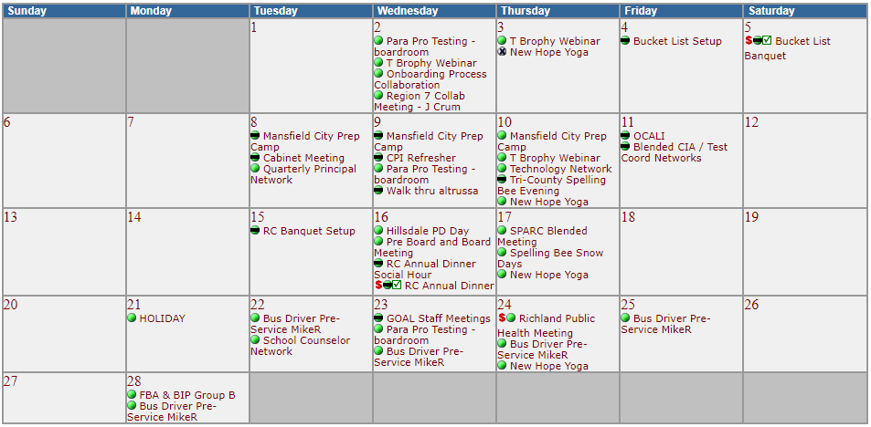

February 2021 – 1 paid events (February 2020 – 3 paid events)
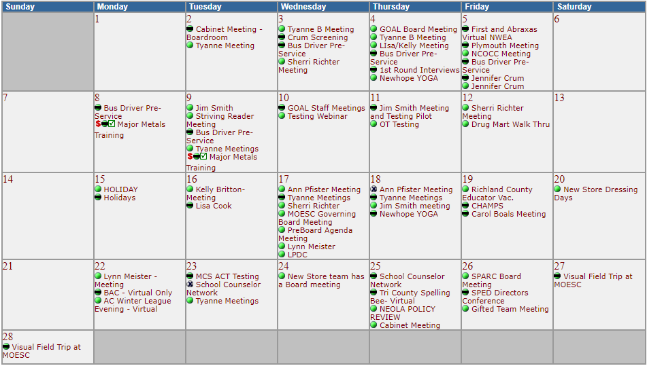

- Fingerprinting -
    - thru January 2022 – 1,271 prints, $22,499 margin
    - avg. thru January (Pre-COVID) – 1,665 prints, $22,577 margin
- Print Shop -
    - thru December 2021 - $1,030 margin
    - thru December 2020 - $(12,131) margin

- GOAL Digital Academy -
    - FTE’s = 700 in 2022 and 775 in 2021

- Tomorrow Center -
    - FTE’s = 87 in 2022 and 87 in 2021

