Executive Director Update – Steve Earnest

- MOCC -
January 2022 – 0 paid events
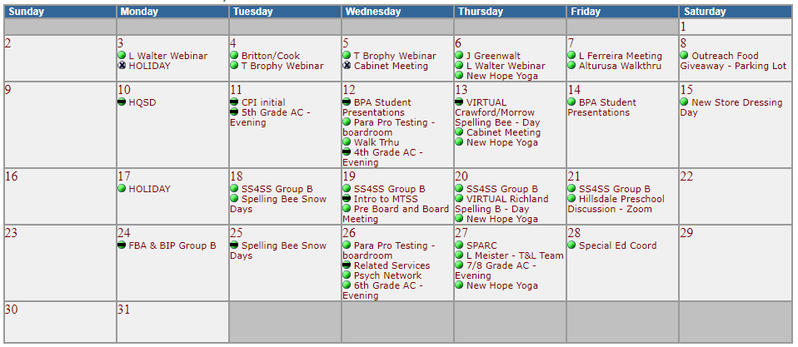
  - January 2021 – 0 paid events (January 2020 – 2 paid events)
  - 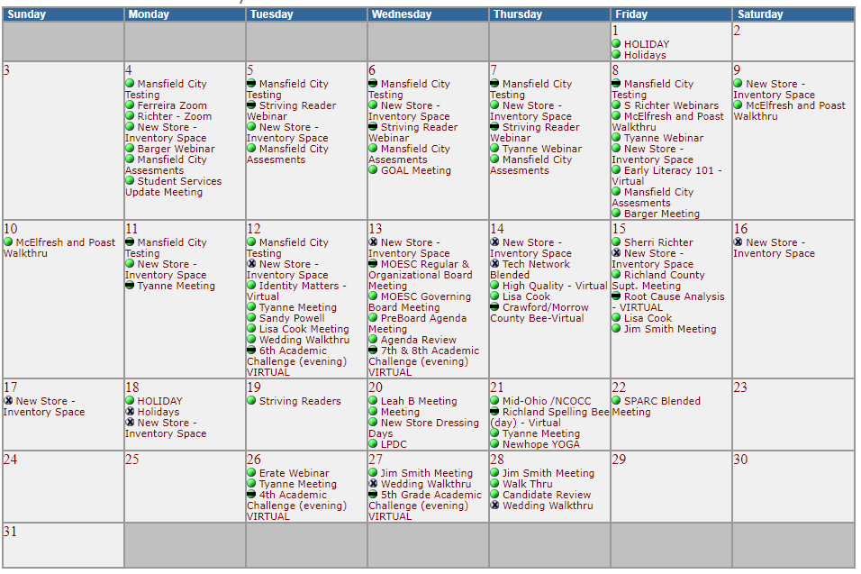

- Fingerprinting -
    - thru December 2021 – 1,092 prints, $19,798 margin
    - thru December 2020 – 1,039 prints, $18,603 margin
    - thru December 2019 – 1,548 prints, $20,018 margin
- Print Shop -
    - thru December 2021 - $1,030 margin
    - thru December 2020 - $(12,131) margin
- GOAL Digital Academy -
    - FTE’s = 700 in 2022 and 770 in 2021
    - GOAL maintained its “Drop Out” status for FY22
- Tomorrow Center -
    - FTE’s = 87 in 2022 and 82 in 2021

