Board Report
December 2021

Esports Update
MOESC concluded the Esports survey and based on the survey results we are going to move forward in investigating bringing Esports to Mid-Ohio. We will work closely with Esports experts to design a program that meets the needs of our local school districts.

Leadership Supports
Lucas
On November 30, 2021, I worked directly with elementary BLT on mission and vision alignment. Lucas’s leadership team is taking actions to bring meaning to the district’s mission and vision, as well as, making actionable plans to carry out the mission/vision.

Pleasant
I met with Pleasant Superintendent Jennifer Adams to discuss the Pleasant’s needs and possible supports. I have a meeting scheduled for December 9th, with Mrs. Adams and the high school principal to begin the needs assessment and action planning.

Galion
I provided a leadership training to Galion’s entire administrative team on November 29, 2021. The team took a deeper dive into Galion’s mission and vision and began the process to create action steps.

Superintendent Lunch and Learn
Dr. Riegel and I presented at our latest Leader Lunch and Learn on Friday, December 3, 2021. We provided training and supports in supporting the Whole Child Framework issued by the Ohio Department of Education. Below you will see some of the worksheet and information we shared. A video is being created for the leaders who were unable to attend, a link can be shared with the Board when completed. You will also find a link to the PowerPoint we presented.
Link to the PowerPoint: https://docs.google.com/presentation/d/1oVeCBUgGvXrprtRtEOc7Mo34z2wzdFm6/edit#slide=id.p3
Agenda

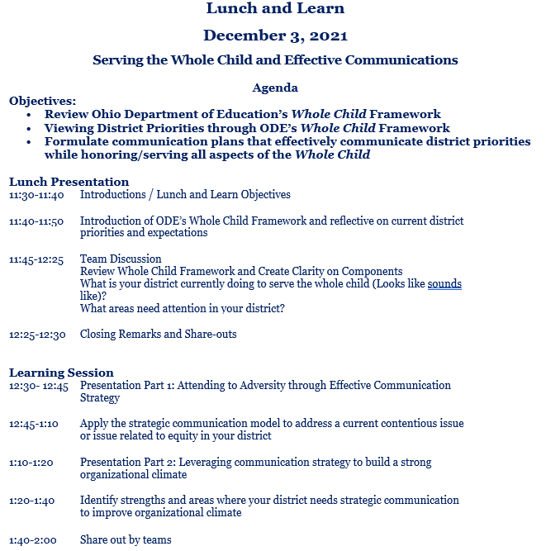

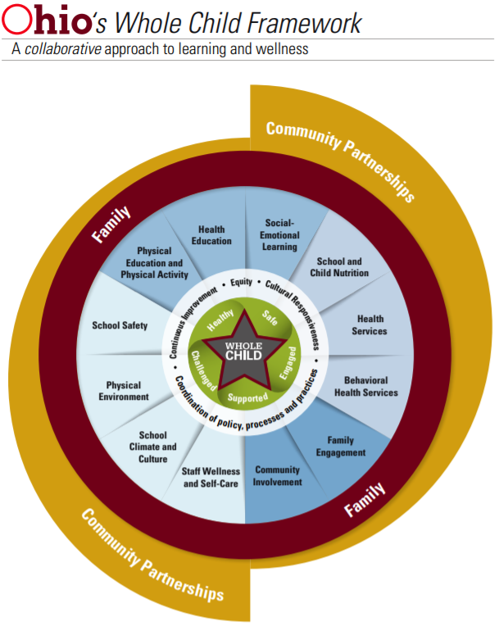

Whole Child Framework Descriptors

Physical Education and Physical Activity
Schools can create environments that offer many opportunities for students to be physically active throughout the school day. A comprehensive school physical activity program reflects strong coordination across five components: physical education, physical activity during school, physical activity before and after school, staff involvement, and family and community engagement.

Health Education
Formal, structured health education consists of any combination of planned learning experiences that provide opportunities for students to acquire the information and skills they need to make quality health decisions. Ohio law provides clarification about the content to be addressed in Ohio’s health education classroom settings. When provided by qualified, trained teachers, health education helps students acquire the knowledge, attitudes and skills they need for making health-promoting decisions, achieving health literacy, adopting health-enhancing behaviors and promoting the health of others. Health education based on assessment of students’ health needs and planned in collaboration with families and the local community ensures reinforcement of health messages that are relevant for students and meet community needs.

Social-Emotional Learning
An environment supporting the whole child incorporates the important work of social-emotional learning. Like academic subject areas such as science and mathematics, social-emotional learning is a key ingredient to challenging and preparing Ohio’s students to become resilient, persistent, lifelong learners. Students with strong social and emotional foundations are better able to interact with others in their schools, communities and homes and later in their workplaces.

School and Child Nutrition
School nutrition services provide meals and, optionally, a la carte items that meet federal nutrition standards for the National School Lunch and Breakfast Programs and Smart Snacks program. The school nutrition environment also provides students with opportunities to learn about and practice healthy eating through available foods and beverages, nutrition education and messages in the cafeteria and throughout the school campus. Schools may work with community partners to address food insecurities of families.

Health Services
As defined by the World Health Organization (WHO), health is a state of complete physical, mental and social well-being. School health services help ensure students’ physical, mental and social-emotional health needs are met to best support the whole child.

Behavioral Health Services
The school provides a range of mental health promotion, prevention, counseling and psychological services to support the behavioral health of students and promote success in the learning process. School personnel serve as liaisons who can help students and their caregivers identify the supports and services available to improve their academic success and well-being. These services can be a part of a framework, like Positive Behavioral Interventions and Supports (PBIS) or a Multi-Tiered System of Support (MTSS). These frameworks build positive mental and behavioral health for all students (Tier I, universal supports); provide early interventions to small groups of students who need additional supports (Tier II); and individual interventions provided to students demonstrating persistent challenges (Tier III).

Family Engagement
Family engagement is a school’s explicit inclusion of families in their children’s learning and educational experiences. Schools create systematic and multiple ways for families to engage and contribute to their children’s education and school. Schools design family engagement activities that build strong relationships, increase two-way communication between home and school, give families information needed to support learning at home, involve families in decision-making, provide opportunities for them to volunteer and support families through partnerships with community organizations.

Community Involvement
Community groups, organizations and local businesses create partnerships with schools through community planning to share resources and support students’ learning, development and well-being. Schools, students and families benefit when leaders and staff at the district or school solicit and coordinate information, resources and services available from community-based organizations, businesses, cultural and civic organizations, social services agencies, faith-based organizations, health clinics, and colleges and universities. Collaborating to ensure community resources are accessible and available to all is essential to effective community partnerships between schools and organizations. Community organizations have a wealth of knowledge, resources and services that can ensure families and students are connected with supports to address their health, safety, college and career readiness, learning and development.

School Climate and Culture
School climate and culture refer to the quality and character of school life for students, staff and families. School climate includes the beliefs, values, attitudes and norms routinely demonstrated in the school, including a commitment to equity, racial and social justice. A positive school climate helps everyone feel safe, engaged, supported and connected to the school, which is critical for student success. Districts determine school climate through implementation of policies and practices that prevent challenging issues, address the impact of trauma on a student and help adults respond more effectively when issues arise.

School Safety
A safe school addresses the emotional and physical safety of students and staff by using a comprehensive approach that engages the school’s staff, students, families and community. The school establishes emotional safety by creating a climate that is inclusive and supportive and builds positive relationships among students and staff. The school implements strategies to prevent emotional harm and builds resiliency, including teaching students social and emotional skills, supporting students’ behavioral health needs, addressing bullying of various forms (physical, verbal, social, cyber) and reducing risky behaviors such as drug and alcohol use. The school uses threat assessments to determine the severity of threats and resolves conflicts or problems early.

Physical Environment
The physical school environment encompasses the school building and its contents, land on which the school is located and the area surrounding it. A healthy school environment will address a school’s physical condition during normal operation, as well as during renovation (for example, ventilation, moisture, temperature, noise, and natural and artificial lighting, lead abatement, accessibility, mobility). It protects occupants from physical threats (such as crime, violence, traffic and injuries) and biological and chemical agents in the air, water or soil (such as pollution, radon and mold), as well as those that may be brought into the school or on the school grounds (such as pesticides, cleaning agents and other hazardous materials).

Staff Wellness and Self-Care
Schools are much more than places of learning for students. These teaching and learning communities also are work sites that employ individuals collectively working on behalf of students. In addition to educators and administrators, there are support staff and other professionals who transport and provide nutritious meals and snacks to students, provide for students’ physical and mental health needs and ensure the buildings and grounds where students spend their days are safe and well maintained. Meeting the health and safety needs of this workforce is integral to promoting and protecting the health of students and ensuring their academic success and overall well-being.

Looks Like – Sounds Like Activity
Superintendents were asked to review the Whole Child Framework and identify current practices, areas of strength, and areas of concern. The information generated during the reflective activity was used in the afternoon training session.
