Executive Director Update – Steve Earnest

- Facility -
    - Parking Lot - Repair/Repave – began repairing entrance on 11/10/21. Currently, scheduled to be completed by Thanksgiving.
    - Marque - digital banner (Daktronics is still waiting on parts)
    - New Store – scheduled to complete their move to the former Print Shop by Thanksgiving.

- MOCC -
November 2021 – 4 paid events
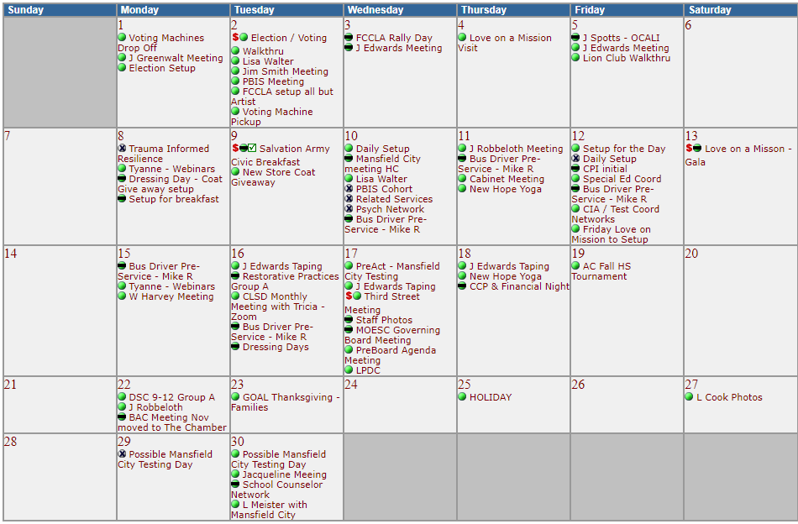

  - November 2020 – 1 paid events
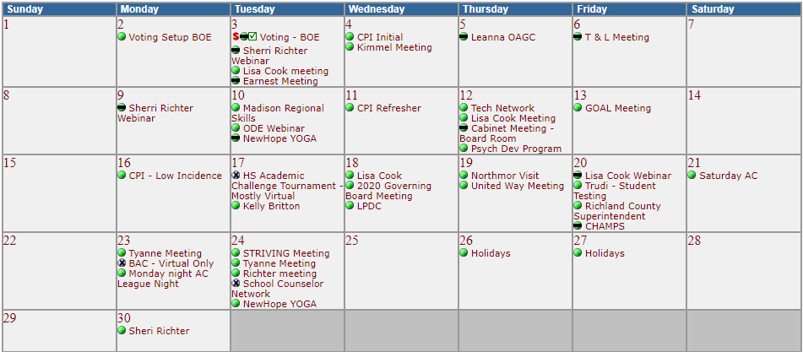

- Fingerprinting -
    - thru October 2021 - 763 prints, $13,020 margin
    - thru October 2020 - 806, $14,967 margin
- Print Shop -
    - thru October 2021 - $9,348 margin
    - thru October 2020 - $(9,061) margin

