Executive Director Update – Steve Earnest

- Facility –
    - Parking Lot Lights - completed 10/13/21 (BP Electrical)
    - Parking Lot - Repair/Repave - scheduled to be completed by the end of October
    - North (rear) of building - $15,500
    - Main entrance from 4th St. to Yield sign - $23,300
    - Marque & Exterior signage - completed with the exception of the digital banner (waiting on parts)
    - New Store - move/renovation - opening has been “punched through” to the Print Shop and east end has been enclosed for maintenance storage.
    - Board Room blinds installed 10/12

- MOCC –
October 2021 – 4 paid events
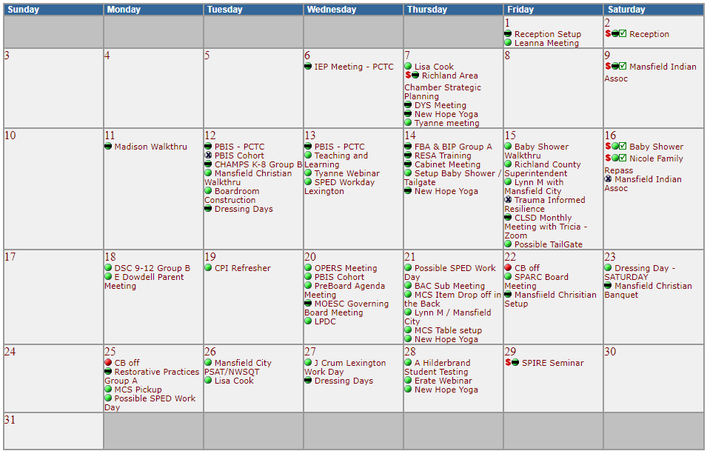

  - October 2020 – 2 paid events
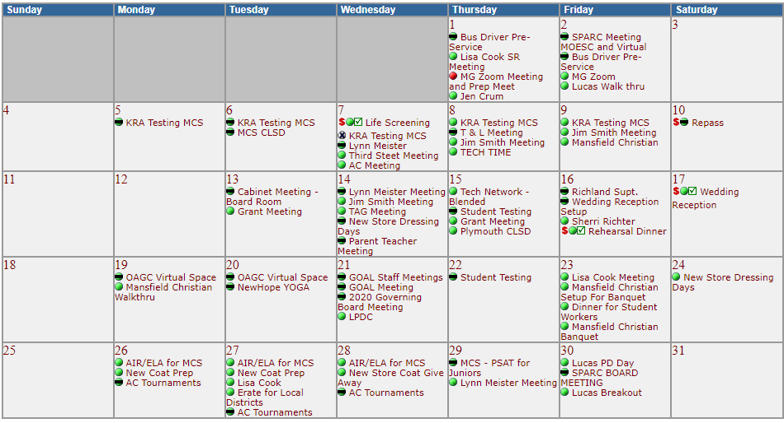

- Fingerprinting-
    - thru September 2021 - 585 prints, $9,854 margin
    - thru September 2020 - 614, $11,368 margin

