Executive Director Update – Steve Earnest

- Facility –
    - Parking Lot Lights - $14,000 (BP Electrical)
    - Parking Lot – repair and sealcoat
    - North (rear) of building - $15,500
    - Main entrance from 4th St. to Yield sign - $23,300
    - Marque sign - should be completed by end of next week (19th)
- MOCC –
September 2021 – 5 paid events
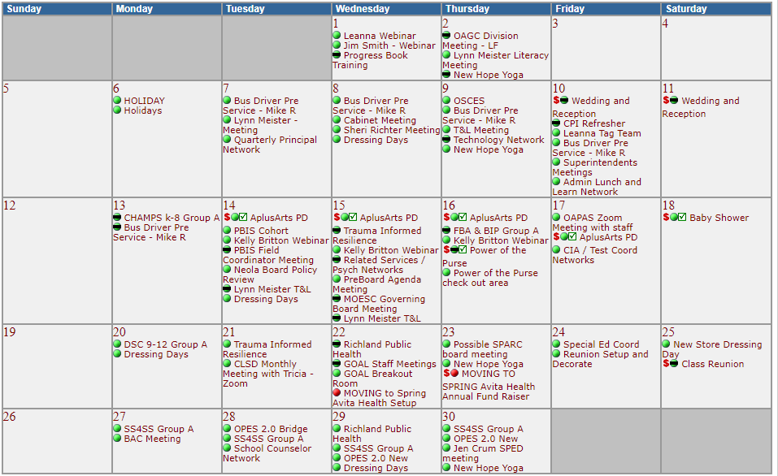

  - September 2020 – 4 paid events

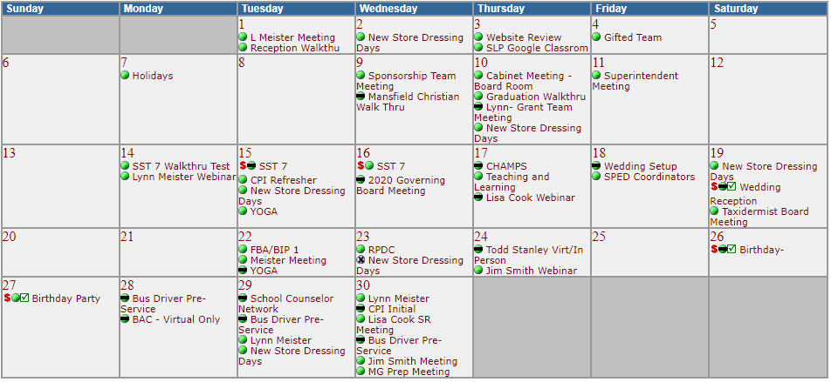

- Fingerprinting-
    - August 2021 - 419 fingerprints, $6,793.35 margin
    - August 2020 - 423 fingerprints, $7,606.75 margin
    - Margin is down due to the more individual prints (BCI or FBI) being processed in 2021 vs having both printed in 2020
- The LEAP Program –
    - 25 students currently enrolled representing 10 districts. Student really enjoy the “collegiate” feel of LEAP-Mansfield

