Executive Director Update – Steve Earnest

- Facility –
  - The LEAP Program has moved into their space and the first day of school will be Thursday, August 19th. Fortunately, the transition has been uneventful thus far.
  - The outside of the building that was once “green” is now “Mid-Ohio blue”. We will be soliciting quotes to “refresh” the beige paint as well.
  - Wall in the Reception area has been painted “Mid-Ohio blue” as well. It was formerly beige. It is our intention to create a wall similar to what Tri-Rivers currently has in its Board Room.

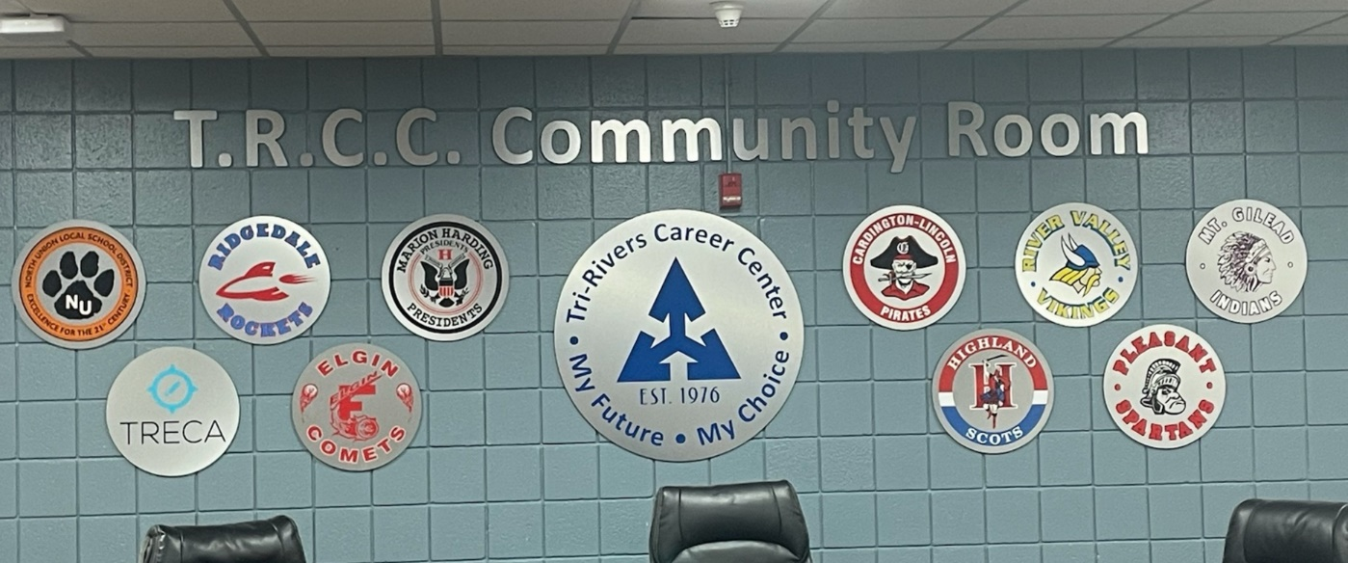

  - Solid window blinds have been ordered for the Board Room. This should complete the Zoom Room updates.
  - We are working with Speer Mechanical to develop a schedule for the HVAC renovation that are being recommended on the August 18, 2021 board agenda.
  - We are currently requesting quotes for repair and sealcoating of the parking lot.
- MOCC –
August 2021 – 5 paid events
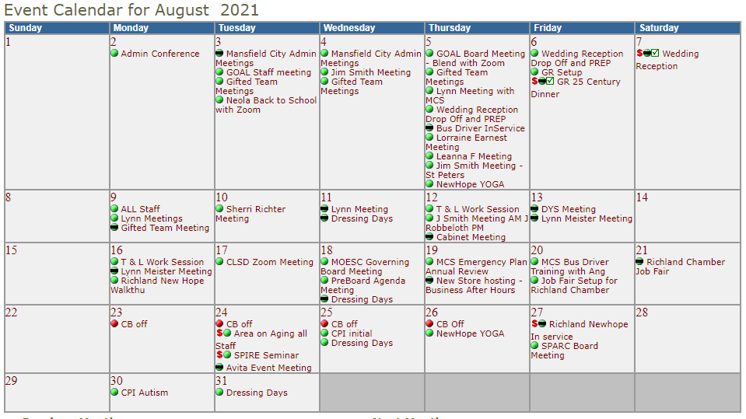

  - August 2020 – 4 paid events

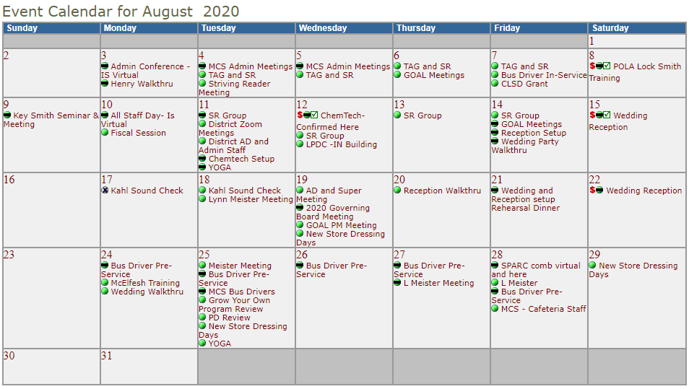

- Fingerprinting-
    - July 2021 - 212 fingerprints, $2,866.50 margin
    - July 2020 - 178 fingerprints, $2,801.75 margin

