Executive Director Update – Steve Earnest

- District Contracts –
  - All the “Estimated” contracts were sent to the Districts on Friday, May 28, 2021. Plymouth has returned their already and is on board agenda or approval.
- Facility –
  - The LEAP Program’s space is almost ready for their occupancy. According to LEAP, they will begin moving sometime the week of June 14th.
  - Exterior painting – we are requesting quotes to paint the front of the building. Looking to refresh the beige paint and change the green to “Mid-Ohio blue”.
  - Created a Zoom Room within the board room. This required updated technology hardware and software.
- MOCC –
June 2020 – 0 paid events
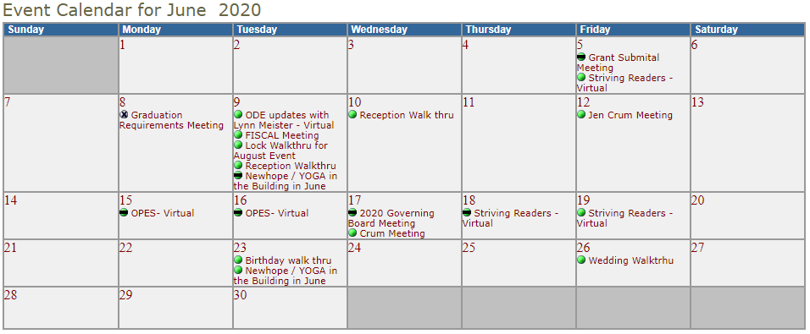
  - June 2021 – 5 paid events
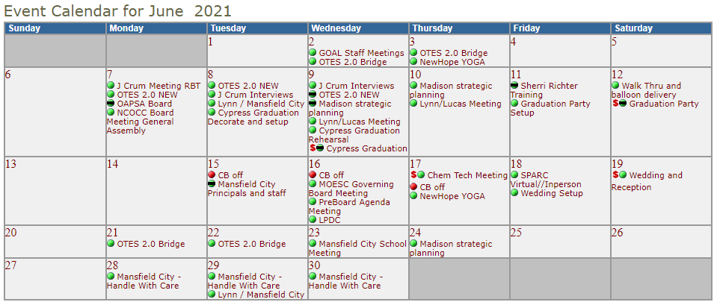

- Fingerprinting-
  - We are still fingerprinting by appointment only. The overall number of fingerprints has declined due to Covid. However, Mid-Ohio’s “margin” has improved as a result of a price increase that went into effect 7/1/2020.
    - FY21 - 1,786 fingerprints, $33,277 margin
    - Avg (non-Covid year) - 2,631 fingerprints, $30,016 margin

- Community Schools
Tomorrow Center
- 87 funded FTE’s. Enrollment is down this year because of Covid. Last year Tomorrow Center had 112 funded FTE’s.
- Tomorrow Center graduated 17 students on May 21, 2021.
GOAL Digital Academy
- experiencing large elementary enrollment due to Covid. Currently, their funded enrollment is 769 compared to 650 last year.
- GOAL graduated 104 students on Friday, May 21, 2021.

