Executive Director Update – Steve Earnest

- District Contracts –
  - Updated District Contracts were sent to the districts in late-February. On March 10th we will have completed our district visits to discuss the Updated (True-Up) District Contract, future services and upcoming Mid-Ohio events.
- Facility –
  - Interior Painting – The maintenance team is still painting the interior of the facility and will continue to do so thru the month of March.
  - Exterior Painting – The maintenance team will begin pressure washing, repairing and painting the north and east sides of the buildings as soon as the weather breaks.
- MOCC –
  - March 2020 – 4 paid events
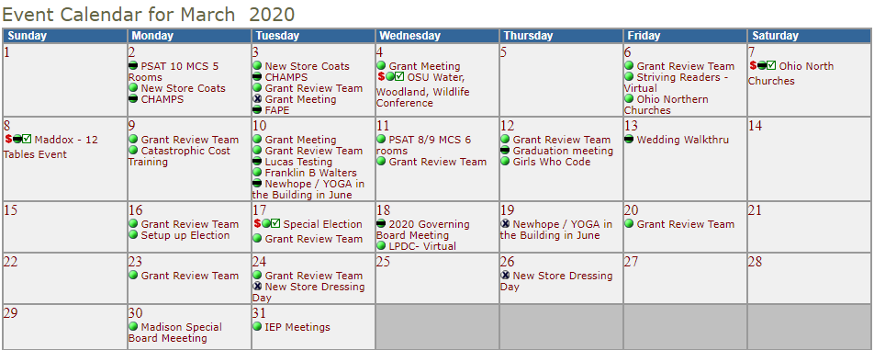
  - March 2021 – 3 paid events
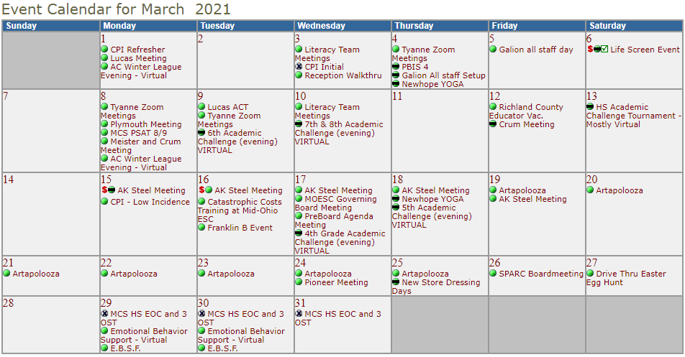
- Fingerprinting-
  - We are still fingerprinting by appointment only. The overall number of fingerprints has declined due to Covid. However, Mid-Ohio’s “margin” has remained the same as a result of price increase that went into effect 7/1/2020.

- Community Schools
Tomorrow Center – 87 funded FTE’s. Enrollment is down this year because of Covid. Last year Tomorrow Center had 112 funded FTE’s.
GOAL Digital Academy – experiencing large elementary enrollment due to Covid. Currently, their funded enrollment is 775 compared to 650 last year.

