Executive Director Update – Steve Earnest

- Facility –
  - Sign – Kessler’s is working with their production company to provide a schedule for the new sign installation.
  - Painting – The maintenance team is in the midst of painting the interior walls and door frames within the conference center.

- MOCC –
  - December 2019 – 9 paid events
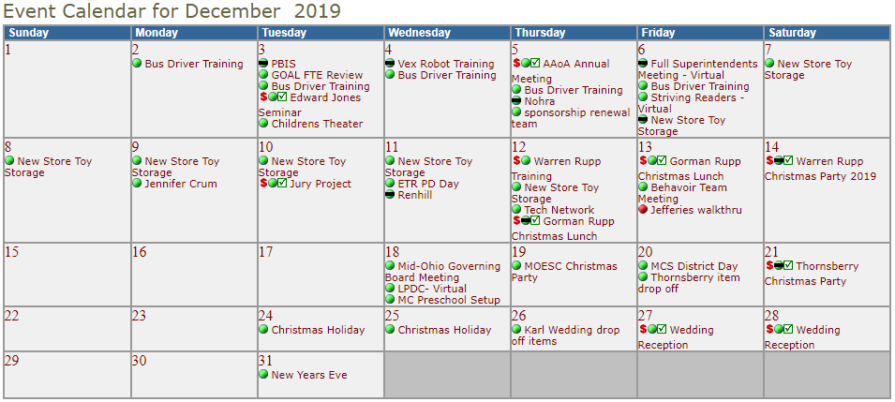
  - December 2020 – 1 paid events – due to COVID-19
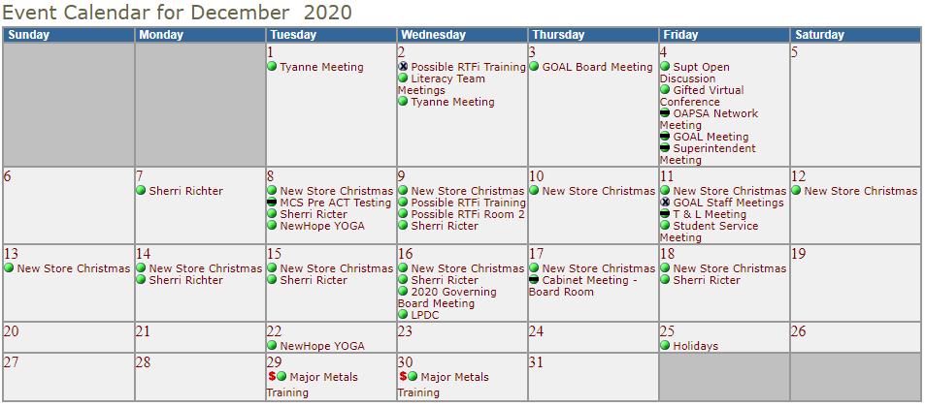

- Fingerprinting-
  - We are still fingerprinting by appointment only.
  - Year-to-Year Comparison:
    - July-November 2019 – 1,323 prints, $17,815 margin
    - July-November 2020 - 939 print, $17,477 margin
Because of the price increase that took effect on 7/1/20, we are able to keep “margins/profit” at, or near, 2020 levels.

- Community Schools

Tomorrow Center - 90 students with 9 attending Tri-Rivers / enrollment is down this year because of COVID19. Last year Tomorrow Center had 112 students

GOAL Digital Academy – experienced large elementary enrollment requests because of COVID19. Currently, their funded enrollment is 800+ compared to 650 last year.

