Executive Director Update – Steve Earnest

- Facility –
  - Generator – Mid-Ohio finally received a “soft” quote for a backup generator large enough for the entire facility. The estimated cost of this backup generator is between $175,000 and $225,000.

We also received a quote for a backup generator to support the Conference Center space. That quote was $63,000. This will most likely accommodate the needs of NCOCC, should they decide to move into Mid-Ohio facility.

  - Mezzanine/Records Disposal – The records approved by the Records Committee have all been properly disposed of by Shred-It.

  - Sign – Received two additional quotes for replacing the sign wrap and retrofitting it with LED lighting. The lowest quote was $5,250 for the sign wrap and $1,950 for LED lighting. The vendor is planning to begin sign production and replacement after their “contract” is approved at the November 18th board meeting.

- MOCC –
  - November 2019 – 8 paid events
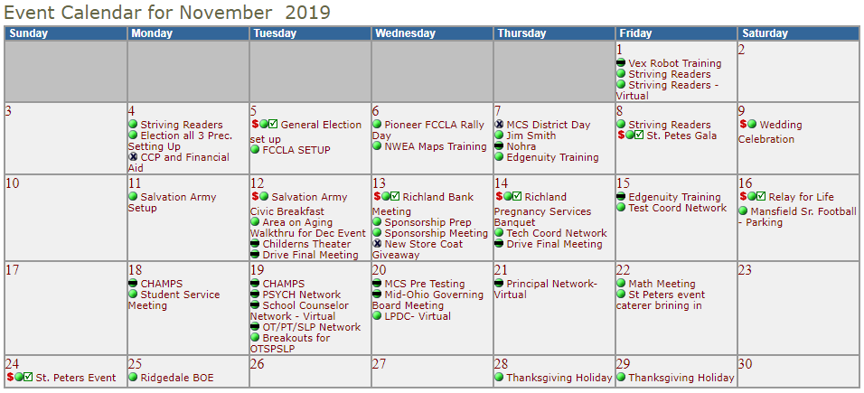
  - November 2020 – 0 paid events – due to COVID-19
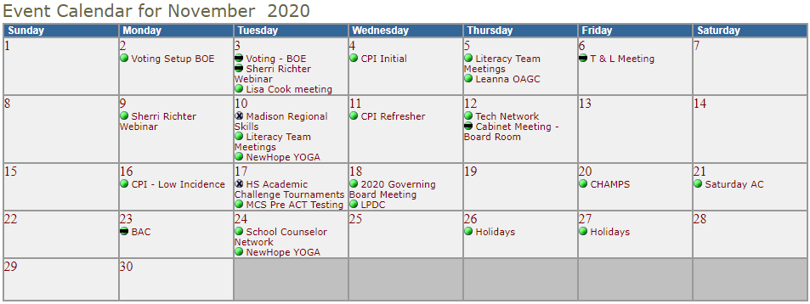

- Fingerprinting-
  - We are still fingerprinting by appointment only. Most days the appointment book is full. According to our fingerprinting staff, they feel safe working in the environment that was created for them.
  - Year-to-Year Comparison:
    - July-October 2019 – 1,098 prints, $15,063 margin
    - July-October 2020 - 806 print, $14,967 margin
Because of the price increase that took effect on 7/1/20, we can keep “margins/profit” at, or near, 2019 levels.

- Community Schools

Tomorrow Center - 90 students with 9 attending Tri-Rivers / enrollment is down this year because of COVID19. Last year Tomorrow Center had 112 students

GOAL Digital Academy – experienced large elementary enrollment requests because of COVID19. Currently, their enrollment is around 800 students compared to 650 last year.

