Executive Director Update – Steve Earnest

- Facility –
  - Cleaning – purchased sanitizer/mister machines to more effectively clean the offices and conference center. In addition, purchased two Kiavac (hard surface cleaners) for the bathrooms, kitchens and other hard surface areas. This equipment was paid out of the GEER funds.

  - Generator – I apologize, but it has been impossible to get the two remaining quotes from Alpine Electric. Thus, we have requested quotes from other electric companies. We are asking for “soft” quotes to help better understand the costs of moving NCOCC to the Mid-Ohio facility.

  - Mezzanine/Records Disposal – Shred-It was overwhelmed with the amount of records we were asking them to shred. Thus, they were only able to shred about 2/3^{rds} of the records during the time that was allotted. To date, we have not been able to get back on their schedule for the disposal of the remaining records.

  - Sign – Received two additional quotes for replacing the sign wrap and retrofitting it with LED lighting. The lowest quote was $5,250 for the sign wrap and $1,950 for LED lighting.

- MOCC –
  - October 2019 – 12 paid events
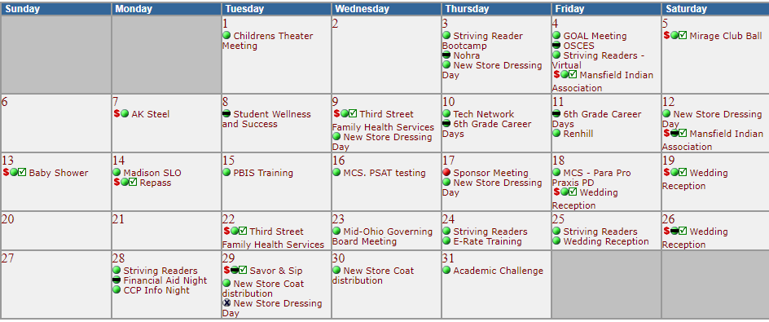

  - October 2020 – 6 paid events

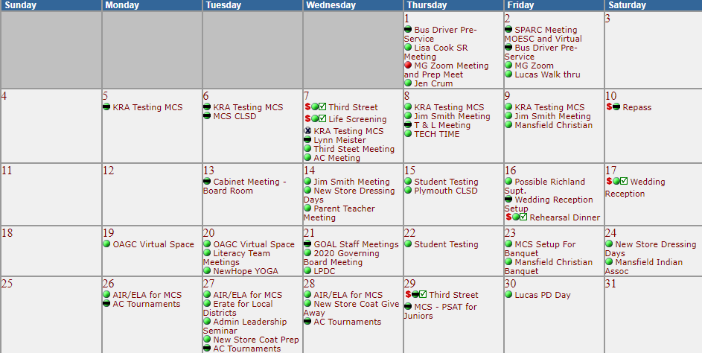

- Fingerprinting-
  - We are still fingerprinting by appointment only. Most days the appointment book is full. According to our fingerprinting staff, they feel safe working in the environment that was created for them.
  - Year-to-Year Comparison:
    - July-September 2019 – 900 prints, $11,638 margin
    - July-September 2020 - 614 print, $11,368 margin

- Community Schools

Tomorrow Center - 90 students with 9 attending Tri-Rivers / enrollment is down this year as a result of COVID19. Last year Tomorrow Center had 112 students

GOAL Digital Academy – experienced large elementary enrollment requests as a result of COVID19. Currently, their enrollment is around 800 students compared to 650 last year.

