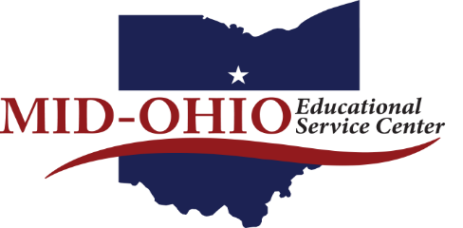

Teaching and Learning Team Update
Lynn Meister, Director of Teaching and Learning
May 20, 2020

District Service
As described in the April update, the Teaching and Learning team completed a monumental project to move all K - 12 ELA, Mathematics, and disciplinary literacy professional development into an online format. There are four sites, one each for our contracted districts of Crestline, Lucas, Galion, and Northmor. Each site has content chosen specifically for the district’s needs. The sites house dozens of Google Classrooms with extensive modules, resources, and “assignments” for teachers to study and then interact with team members. Each district’s site and the online professional development housed within were customized to replicate the professional development the team would have provided in person throughout the rest of the school year. Teachers are earning CEUs or graduate credit from Ashland University for successful completion of the modules.
In addition to monitoring all the Google Classrooms, team members are providing professional development and individual/group support through Zoom meetings, blogs, emails, and phone calls to teachers and administrators to provide personal contact through mid-June.

Networking Meeting
The final Curriculum, Instruction, and Assessment meeting was April 24, conducted as a Zoom session. The curriculum directors examined important topics such as OTES 2.0, gifted mandates, sharing resources for reaching students, and maintaining staff morale. The directors requested that Mid-Ohio create a virtual, password-protected bulletin board where they could share drafts of policies and other documents. Candy Bores is assisting with this project.

ODE’s New Literacy Grant
I am working with Lisa Cook, Carrie Wood, and Sherri Richter to write ODE’s new Comprehensive Literacy Consortium Grant. My tasks range from writing responsibilities to data analysis and editing. If awarded to Mid-Ohio, grant funds will provide English/Language Arts professional development, coaching, and training from members of the Teaching and Learning team. Grants will be awarded in August 2020. Besides impacting Mansfield City Schools’ Springmill STEM Elementary and Plymouth-Shiloh Elementary, the Teaching and Learning team will use the project’s outcomes to impact all Mid-Ohio districts’ literacy programs.

